Practical
SUMMARY:-
This practical demonstrated the implementation of Linear Search and Binary Search in C. It helped understand how both algorithms search for an element and compare their efficiency.
Linear Search checks each element one by one until the target element is found or the array ends.
Output
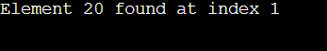
Time Complexity
Case Time Complexity
Best Case O(1)
Average Case O(n)
Worst Case O(n)

Binary Search repeatedly divides a sorted array into two halves to quickly find the target element.
Output
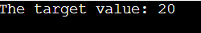
Time Complexity
Case Time Complexity
Best Case O(1)
Average Case O(log n)
Worst Case O(log n)
Conclusion
We learned that Linear Search works on any array but is slower, while Binary Search is faster and more efficient for sorted arrays.

